**Data Warehousing and Data Mining.**

**Name : Antuley Aman Siraj.**

**Roll No. : 23CO25.**

**Class : TE-CO**

**Batch : 01**

**Experiment - 02**

### **Aim :**

To design **Star, Snowflake, and Fact Constellation** Schemas for an **Online Food Delivery System,** enabling structured and integrated data for efficient analysis and business intelligence.

### **Introduction:**

This experiment focuses on the design of dimensional schemas for a data warehouse supporting an **Online Food Delivery System**. The purpose is to model data efficiently from various sources such as users, orders, restaurants, deliveries, and payments to support reporting, OLAP analysis, and strategic decision-making.

### **Background:**

FoodFast, a major food delivery platform, collects large volumes of data from users, restaurants, and delivery partners. However, analyzing this scattered operational data was challenging. To address this, FoodFast initiated the design of a data warehouse. In this experiment, three common warehouse schema models **Star Schema**, **Snowflake Schema**, and **Fact Constellation Schema** are designed to represent the same business data with different levels of normalization.

### **Objectives:**

1. To understand dimensional modeling using fact and dimension tables.
2. To design a **Star Schema** with denormalized dimensions for performance.
3. To design a **Snowflake Schema** with normalized dimensions for consistency.
4. To create a **Fact Constellation Schema** for complex data marts and shared dimensions.
5. To represent entities such as **Users**, **Orders**, **Restaurants**, **Dishes**, **Delivery Partners**, and **Payments**.

### **Entities Identified:**

* Users
* Orders
* Restaurants
* Dishes
* Delivery Partners
* Payment Transactions

### **Schema Designs:**

#### **1. Star Schema:**

* A central **Orders Fact Table** linked directly to all dimension tables: Users, Restaurants, Dishes, Delivery Partners, and Payments.
* Optimized for **fast query performance** and **simple OLAP operations** due to its **denormalized structure**.

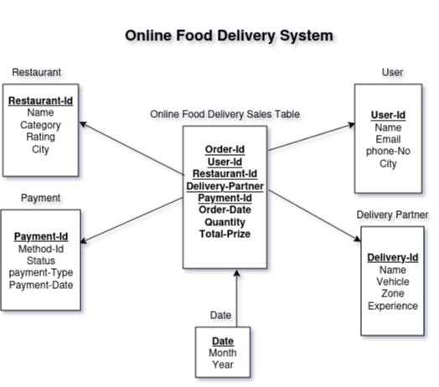

#### **2. Snowflake Schema:**

* Same as the Star Schema but with normalized dimension tables like City, Cuisine, Vehicle Type, etc., forming branching structures.  
  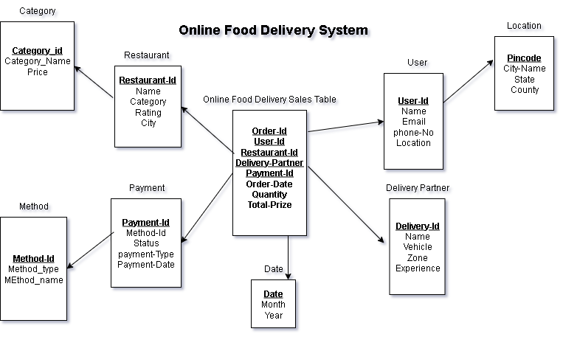

#### **3. Fact Constellation Schema:**

* Multiple fact tables (Orders, Deliveries, Payments) share common dimensions, allowing detailed multi-subject analysis.  
  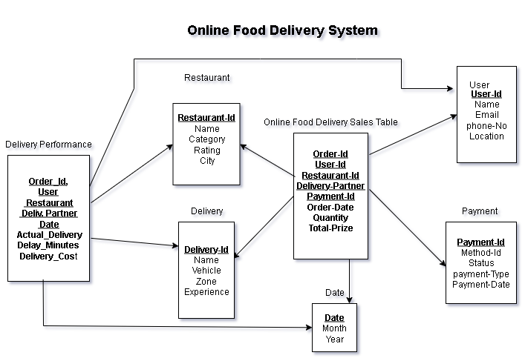

### **Conclusion:**

By designing the **Star**, **Snowflake**, and **Fact Constellation Schemas** for the online food delivery system, we structured operational data for business analytics. These schemas support faster querying, improved reporting, and multidimensional analysis for better decision-making in platforms like **FoodFast**.